Sprawozdanie

Ćwiczenie 6

# 1.Cel ćwiczenia

Celem ćwiczenia jest pomiar ilorazu e/m ładunku i masy elektronu oraz wyznaczenie niepewności standardowej i błędu granicznego pomiaru e/m.

# 2.Wykres.

Wykres zależności napięcia do natężenia.

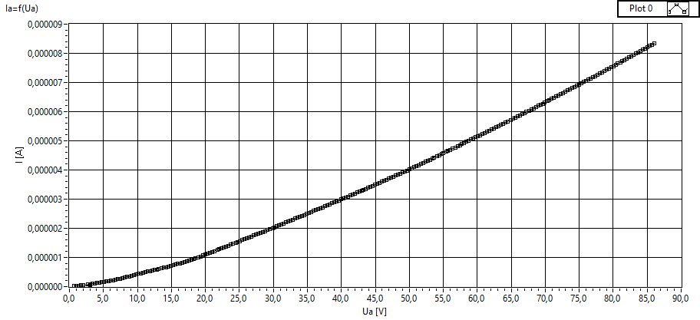

# 3. Wzory i stałe.

Zależność natężenia prądu termoemisji elektronowej w funkcji napięcia przyspieszającego katoda –anoda

$$I=\frac{8Πε0}{9ra }{(\frac{2e}{m})}^{\frac{1}{2}}U^{\frac{3}{2}}L\frac{1}{{β }^{2}}$$

$$\frac{e}{m}=k\frac{I^{2}}{U^{3}}$$

$$k=\frac{81ra^{2}β^{2}}{128ε0^{2}{Π }^{2}L^{2}}$$

k=1,37259E+21

efektywna długość katody : L= 0,00534 m

β =1,081

promień anody : ra= 0,00592 m

𝜺 = 8,8541E-12

Niepewność pomiarowa:

$$ΔUa = 0, 0045\%odcz + 0, 0006\% * 100V$$

$$ΔUro = 0, 0040\%odcz + 0, 0007\% * 1V$$

$$Δro = 0, 1\%$$

$$\frac{de}{dUam}∙ΔUa=-\frac{3UrO^{2}}{{Ua}^{4}∙{Ro}^{2}}∙ΔUa$$

$$\frac{de}{dUam}∙ΔUa=-\frac{2Uro}{{Ua}^{3}∙{Ro}^{2}}∙ΔR_{0}$$

$$\frac{de}{dUam}∙ΔUa=-\frac{2UrO^{2}}{{Ua}^{3}∙Ro}∙ΔR_{0}$$

$$u\left(\frac{e}{m}\right)=k\sqrt{{(\frac{2Ur}{R^{2}U^{3}})}^{2}∙u^{2}\left(Ur\right)+{\left(\frac{-3Ur^{2}}{R^{2}U^{4}}\right)}^{2}∙u^{2}\left(U\right)+{\left(\frac{{-2}^{2}}{R^{3}U^{3}}\right)}^{2}∙u^{2}(R)}$$

# 4.Wyniki

e/m średnie: 1,32064

Niepewność średnia: 4,16885E+8

Błąd średni: 0,0237028

# 5.Wnioski

Wraz z wzrostem napięcia, błąd pomiarowy staje się bardziej precyzyjny.

# 6.Schemat oraz tabela

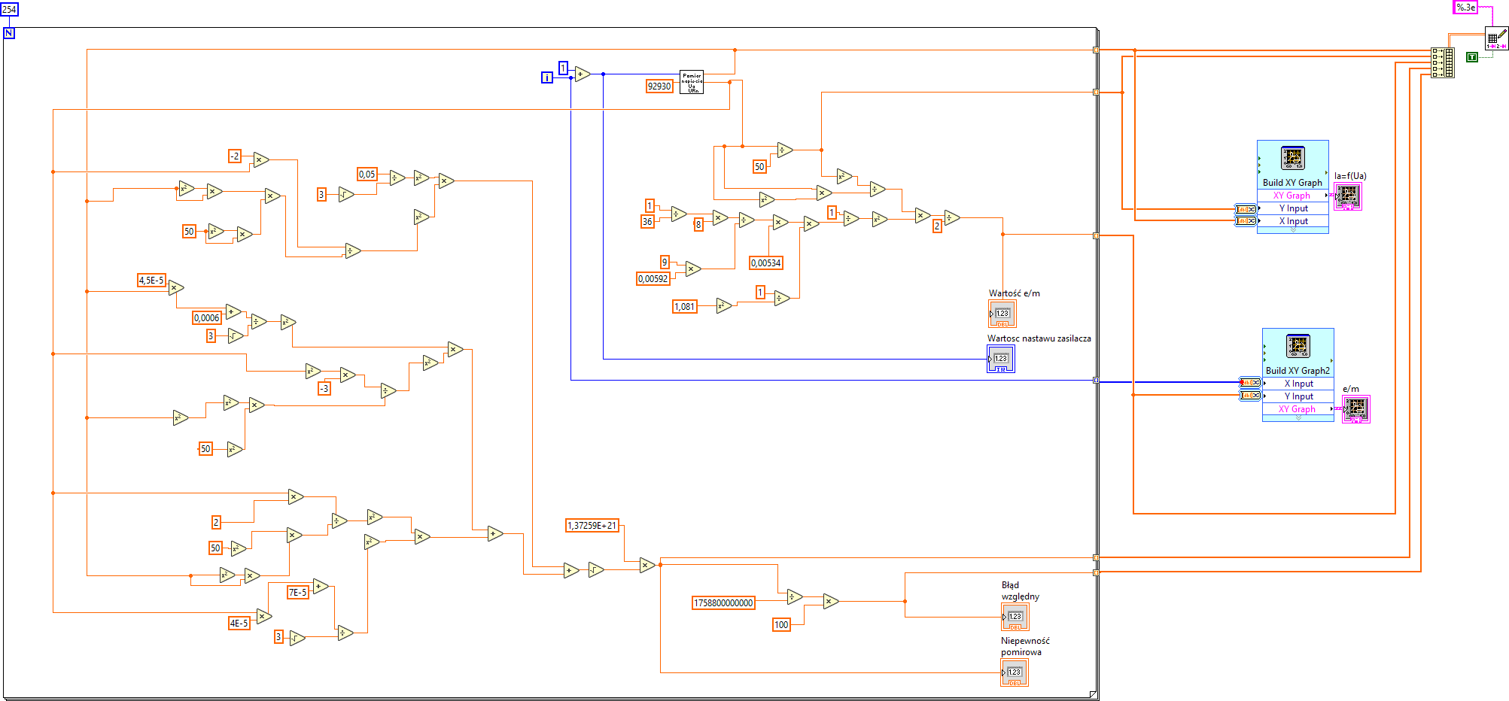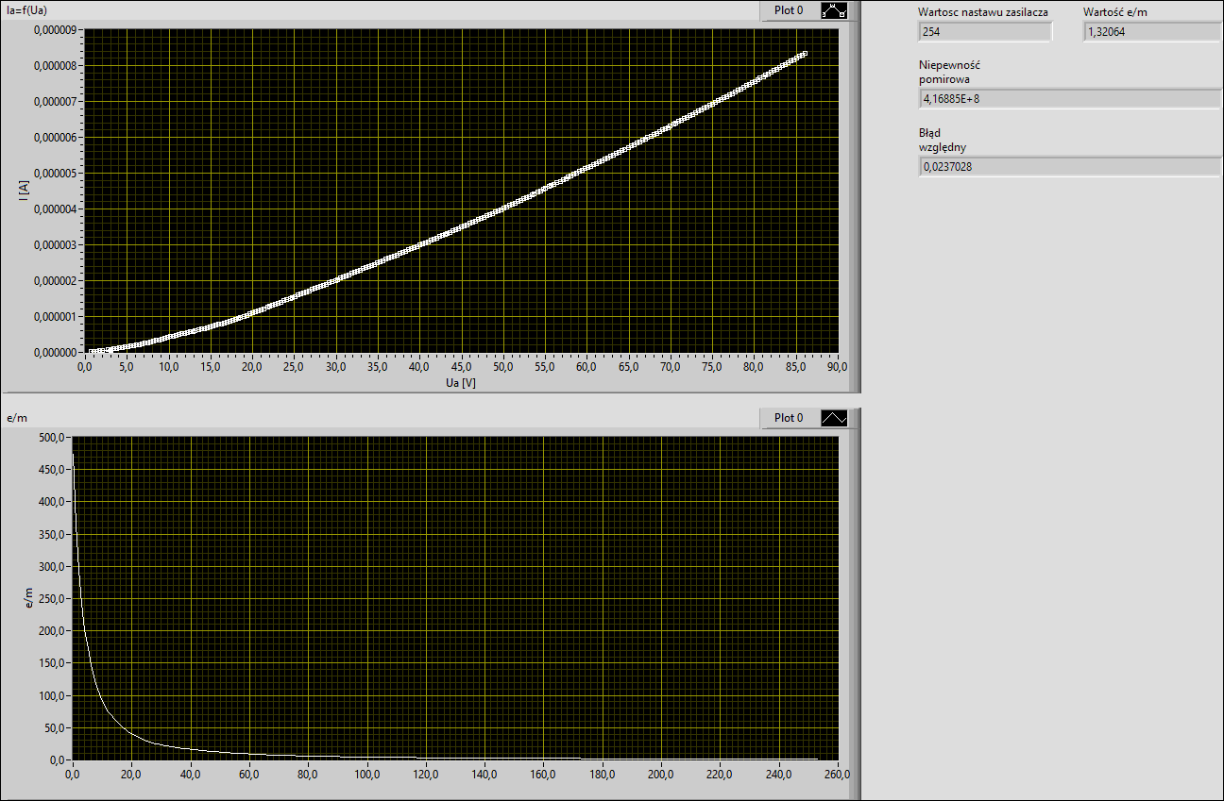

|  |  |  |  |  |
| --- | --- | --- | --- | --- |
| U[V] | I[A] | e/m[C/kg] | niepewność pomiarowa[C/kg] | błąd względny % |

|  |  |  |  |  |
| --- | --- | --- | --- | --- |
| 6,53E-01 | 2,32E-05 | 4,74E+02 | 2,66E+12 | 1,51E+02 |
| 9,79E-01 | 3,03E-05 | 3,64E+02 | 1,03E+12 | 5,83E+01 |
| 1,33E+00 | 3,73E-05 | 2,95E+02 | 5,08E+11 | 2,89E+01 |
| 1,65E+00 | 4,54E-05 | 2,42E+02 | 3,20E+11 | 1,82E+01 |
| 2,00E+00 | 5,45E-05 | 2,02E+02 | 2,18E+11 | 1,24E+01 |
| 3,03E+00 | 6,36E-05 | 1,73E+02 | 7,29E+10 | 4,14E+00 |
| 2,71E+00 | 7,47E-05 | 1,47E+02 | 1,19E+11 | 6,77E+00 |
| 3,04E+00 | 8,58E-05 | 1,28E+02 | 9,74E+10 | 5,54E+00 |
| 3,38E+00 | 9,69E-05 | 1,14E+02 | 7,98E+10 | 4,54E+00 |
| 3,71E+00 | 1,08E-04 | 1,02E+02 | 6,75E+10 | 3,84E+00 |
| 4,06E+00 | 1,21E-04 | 9,09E+01 | 5,77E+10 | 3,28E+00 |
| 4,38E+00 | 1,33E-04 | 8,27E+01 | 5,04E+10 | 2,87E+00 |
| 4,72E+00 | 1,47E-04 | 7,47E+01 | 4,44E+10 | 2,53E+00 |
| 5,05E+00 | 1,61E-04 | 6,86E+01 | 3,97E+10 | 2,26E+00 |
| 5,41E+00 | 1,76E-04 | 6,27E+01 | 3,53E+10 | 2,01E+00 |
| 5,73E+00 | 1,90E-04 | 5,80E+01 | 3,20E+10 | 1,82E+00 |
| 6,08E+00 | 2,06E-04 | 5,35E+01 | 2,92E+10 | 1,66E+00 |
| 6,40E+00 | 2,21E-04 | 4,98E+01 | 2,68E+10 | 1,52E+00 |
| 6,75E+00 | 2,38E-04 | 4,62E+01 | 2,46E+10 | 1,40E+00 |
| 7,07E+00 | 2,55E-04 | 4,31E+01 | 2,29E+10 | 1,31E+00 |
| 7,42E+00 | 2,74E-04 | 4,03E+01 | 2,13E+10 | 1,21E+00 |
| 7,74E+00 | 2,91E-04 | 3,79E+01 | 1,99E+10 | 1,13E+00 |
| 8,13E+00 | 3,12E-04 | 3,53E+01 | 1,84E+10 | 1,05E+00 |
| 8,46E+00 | 3,31E-04 | 3,33E+01 | 1,74E+10 | 9,90E-01 |
| 8,80E+00 | 3,52E-04 | 3,13E+01 | 1,64E+10 | 9,34E-01 |
| 9,12E+00 | 3,71E-04 | 2,97E+01 | 1,56E+10 | 8,84E-01 |
| 9,48E+00 | 3,94E-04 | 2,80E+01 | 1,47E+10 | 8,36E-01 |
| 9,80E+00 | 4,14E-04 | 2,66E+01 | 1,40E+10 | 7,95E-01 |
| 1,01E+01 | 4,35E-04 | 2,53E+01 | 1,33E+10 | 7,53E-01 |
| 1,05E+01 | 4,54E-04 | 2,42E+01 | 1,26E+10 | 7,16E-01 |
| 1,08E+01 | 4,76E-04 | 2,31E+01 | 1,19E+10 | 6,79E-01 |
| 1,12E+01 | 4,95E-04 | 2,23E+01 | 1,14E+10 | 6,45E-01 |
| 1,15E+01 | 5,14E-04 | 2,14E+01 | 1,08E+10 | 6,12E-01 |
| 1,18E+01 | 5,32E-04 | 2,07E+01 | 1,03E+10 | 5,83E-01 |
| 1,22E+01 | 5,52E-04 | 1,99E+01 | 9,75E+09 | 5,55E-01 |
| 1,25E+01 | 5,70E-04 | 1,93E+01 | 9,31E+09 | 5,29E-01 |
| 1,28E+01 | 5,89E-04 | 1,87E+01 | 8,87E+09 | 5,04E-01 |
| 1,32E+01 | 6,08E-04 | 1,81E+01 | 8,49E+09 | 4,83E-01 |
| 1,36E+01 | 6,30E-04 | 1,75E+01 | 8,05E+09 | 4,58E-01 |
| 1,39E+01 | 6,49E-04 | 1,70E+01 | 7,73E+09 | 4,39E-01 |
| 1,42E+01 | 6,70E-04 | 1,64E+01 | 7,42E+09 | 4,22E-01 |
| 1,45E+01 | 6,90E-04 | 1,60E+01 | 7,14E+09 | 4,06E-01 |
| 1,49E+01 | 7,13E-04 | 1,55E+01 | 6,86E+09 | 3,90E-01 |
| 1,52E+01 | 7,34E-04 | 1,50E+01 | 6,62E+09 | 3,77E-01 |
| 1,56E+01 | 7,57E-04 | 1,46E+01 | 6,39E+09 | 3,63E-01 |
| 1,59E+01 | 7,78E-04 | 1,42E+01 | 6,18E+09 | 3,51E-01 |
| 1,62E+01 | 8,02E-04 | 1,37E+01 | 5,95E+09 | 3,38E-01 |
| 1,66E+01 | 8,26E-04 | 1,33E+01 | 5,77E+09 | 3,28E-01 |
| 1,69E+01 | 8,51E-04 | 1,29E+01 | 5,59E+09 | 3,18E-01 |
| 1,72E+01 | 8,75E-04 | 1,26E+01 | 5,43E+09 | 3,09E-01 |
| 1,76E+01 | 9,01E-04 | 1,22E+01 | 5,27E+09 | 3,00E-01 |
| 1,79E+01 | 9,27E-04 | 1,19E+01 | 5,13E+09 | 2,92E-01 |
| 1,83E+01 | 9,54E-04 | 1,15E+01 | 4,99E+09 | 2,84E-01 |
| 1,86E+01 | 9,79E-04 | 1,13E+01 | 4,86E+09 | 2,76E-01 |
| 1,90E+01 | 1,01E-03 | 1,09E+01 | 4,71E+09 | 2,68E-01 |
| 1,93E+01 | 1,04E-03 | 1,06E+01 | 4,60E+09 | 2,61E-01 |
| 1,96E+01 | 1,07E-03 | 1,03E+01 | 4,48E+09 | 2,55E-01 |
| 2,00E+01 | 1,09E-03 | 1,01E+01 | 4,38E+09 | 2,49E-01 |
| 2,03E+01 | 1,12E-03 | 9,79E+00 | 4,27E+09 | 2,43E-01 |
| 2,06E+01 | 1,15E-03 | 9,55E+00 | 4,17E+09 | 2,37E-01 |
| 2,10E+01 | 1,18E-03 | 9,30E+00 | 4,08E+09 | 2,32E-01 |
| 2,13E+01 | 1,21E-03 | 9,08E+00 | 3,99E+09 | 2,27E-01 |
| 2,17E+01 | 1,25E-03 | 8,81E+00 | 3,87E+09 | 2,20E-01 |
| 2,21E+01 | 1,28E-03 | 8,60E+00 | 3,79E+09 | 2,15E-01 |
| 2,24E+01 | 1,31E-03 | 8,40E+00 | 3,71E+09 | 2,11E-01 |
| 2,27E+01 | 1,34E-03 | 8,21E+00 | 3,63E+09 | 2,07E-01 |
| 2,31E+01 | 1,37E-03 | 8,02E+00 | 3,55E+09 | 2,02E-01 |
| 2,34E+01 | 1,40E-03 | 7,84E+00 | 3,48E+09 | 1,98E-01 |
| 2,37E+01 | 1,44E-03 | 7,67E+00 | 3,41E+09 | 1,94E-01 |
| 2,41E+01 | 1,47E-03 | 7,51E+00 | 3,35E+09 | 1,90E-01 |
| 2,45E+01 | 1,50E-03 | 7,33E+00 | 3,26E+09 | 1,86E-01 |
| 2,48E+01 | 1,53E-03 | 7,18E+00 | 3,20E+09 | 1,82E-01 |
| 2,51E+01 | 1,57E-03 | 7,03E+00 | 3,14E+09 | 1,79E-01 |
| 2,54E+01 | 1,60E-03 | 6,91E+00 | 3,08E+09 | 1,75E-01 |
| 2,58E+01 | 1,63E-03 | 6,76E+00 | 3,01E+09 | 1,71E-01 |
| 2,61E+01 | 1,66E-03 | 6,64E+00 | 2,96E+09 | 1,68E-01 |
| 2,65E+01 | 1,69E-03 | 6,52E+00 | 2,90E+09 | 1,65E-01 |
| 2,68E+01 | 1,72E-03 | 6,40E+00 | 2,85E+09 | 1,62E-01 |
| 2,72E+01 | 1,75E-03 | 6,28E+00 | 2,78E+09 | 1,58E-01 |
| 2,75E+01 | 1,78E-03 | 6,17E+00 | 2,73E+09 | 1,55E-01 |
| 2,78E+01 | 1,82E-03 | 6,07E+00 | 2,68E+09 | 1,52E-01 |
| 2,81E+01 | 1,85E-03 | 5,97E+00 | 2,63E+09 | 1,50E-01 |
| 2,85E+01 | 1,88E-03 | 5,87E+00 | 2,58E+09 | 1,47E-01 |
| 2,88E+01 | 1,91E-03 | 5,77E+00 | 2,54E+09 | 1,44E-01 |
| 2,92E+01 | 1,94E-03 | 5,68E+00 | 2,49E+09 | 1,42E-01 |
| 2,95E+01 | 1,97E-03 | 5,59E+00 | 2,45E+09 | 1,39E-01 |
| 2,99E+01 | 2,01E-03 | 5,49E+00 | 2,39E+09 | 1,36E-01 |
| 3,02E+01 | 2,04E-03 | 5,40E+00 | 2,35E+09 | 1,34E-01 |
| 3,05E+01 | 2,07E-03 | 5,32E+00 | 2,31E+09 | 1,31E-01 |
| 3,09E+01 | 2,10E-03 | 5,24E+00 | 2,27E+09 | 1,29E-01 |
| 3,12E+01 | 2,14E-03 | 5,15E+00 | 2,23E+09 | 1,27E-01 |
| 3,15E+01 | 2,17E-03 | 5,08E+00 | 2,20E+09 | 1,25E-01 |
| 3,19E+01 | 2,20E-03 | 5,00E+00 | 2,16E+09 | 1,23E-01 |
| 3,22E+01 | 2,23E-03 | 4,93E+00 | 2,12E+09 | 1,21E-01 |
| 3,26E+01 | 2,27E-03 | 4,86E+00 | 2,09E+09 | 1,19E-01 |
| 3,29E+01 | 2,30E-03 | 4,80E+00 | 2,05E+09 | 1,17E-01 |
| 3,32E+01 | 2,33E-03 | 4,73E+00 | 2,02E+09 | 1,15E-01 |
| 3,36E+01 | 2,36E-03 | 4,66E+00 | 1,99E+09 | 1,13E-01 |
| 3,39E+01 | 2,39E-03 | 4,60E+00 | 1,95E+09 | 1,11E-01 |
| 3,42E+01 | 2,43E-03 | 4,54E+00 | 1,92E+09 | 1,09E-01 |
| 3,46E+01 | 2,46E-03 | 4,48E+00 | 1,89E+09 | 1,08E-01 |
| 3,49E+01 | 2,49E-03 | 4,42E+00 | 1,87E+09 | 1,06E-01 |
| 3,53E+01 | 2,53E-03 | 4,36E+00 | 1,83E+09 | 1,04E-01 |
| 3,56E+01 | 2,56E-03 | 4,30E+00 | 1,80E+09 | 1,03E-01 |
| 3,60E+01 | 2,59E-03 | 4,25E+00 | 1,78E+09 | 1,01E-01 |
| 3,63E+01 | 2,62E-03 | 4,20E+00 | 1,75E+09 | 9,94E-02 |
| 3,66E+01 | 2,66E-03 | 4,14E+00 | 1,72E+09 | 9,78E-02 |
| 3,70E+01 | 2,69E-03 | 4,09E+00 | 1,70E+09 | 9,64E-02 |
| 3,73E+01 | 2,72E-03 | 4,04E+00 | 1,67E+09 | 9,49E-02 |
| 3,76E+01 | 2,75E-03 | 4,00E+00 | 1,65E+09 | 9,36E-02 |
| 3,80E+01 | 2,79E-03 | 3,95E+00 | 1,62E+09 | 9,20E-02 |
| 3,83E+01 | 2,82E-03 | 3,90E+00 | 1,60E+09 | 9,07E-02 |
| 3,87E+01 | 2,86E-03 | 3,86E+00 | 1,57E+09 | 8,94E-02 |
| 3,90E+01 | 2,89E-03 | 3,81E+00 | 1,55E+09 | 8,82E-02 |
| 3,93E+01 | 2,92E-03 | 3,77E+00 | 1,53E+09 | 8,69E-02 |
| 3,96E+01 | 2,95E-03 | 3,73E+00 | 1,51E+09 | 8,57E-02 |
| 4,00E+01 | 2,99E-03 | 3,69E+00 | 1,49E+09 | 8,45E-02 |
| 4,03E+01 | 3,02E-03 | 3,65E+00 | 1,47E+09 | 8,33E-02 |
| 4,07E+01 | 3,06E-03 | 3,60E+00 | 1,44E+09 | 8,20E-02 |
| 4,10E+01 | 3,09E-03 | 3,56E+00 | 1,42E+09 | 8,09E-02 |
| 4,14E+01 | 3,13E-03 | 3,52E+00 | 1,40E+09 | 7,98E-02 |
| 4,17E+01 | 3,16E-03 | 3,49E+00 | 1,39E+09 | 7,88E-02 |
| 4,21E+01 | 3,19E-03 | 3,45E+00 | 1,37E+09 | 7,77E-02 |
| 4,24E+01 | 3,23E-03 | 3,41E+00 | 1,35E+09 | 7,67E-02 |
| 4,27E+01 | 3,26E-03 | 3,38E+00 | 1,33E+09 | 7,56E-02 |
| 4,31E+01 | 3,30E-03 | 3,34E+00 | 1,31E+09 | 7,47E-02 |
| 4,33E+01 | 3,32E-03 | 3,32E+00 | 1,30E+09 | 7,39E-02 |
| 4,36E+01 | 3,35E-03 | 3,29E+00 | 1,28E+09 | 7,30E-02 |
| 4,40E+01 | 3,39E-03 | 3,25E+00 | 1,27E+09 | 7,21E-02 |
| 4,43E+01 | 3,42E-03 | 3,22E+00 | 1,25E+09 | 7,12E-02 |
| 4,46E+01 | 3,45E-03 | 3,19E+00 | 1,24E+09 | 7,03E-02 |
| 4,50E+01 | 3,49E-03 | 3,16E+00 | 1,22E+09 | 6,94E-02 |
| 4,53E+01 | 3,52E-03 | 3,13E+00 | 1,21E+09 | 6,86E-02 |
| 4,56E+01 | 3,56E-03 | 3,10E+00 | 1,19E+09 | 6,78E-02 |
| 4,60E+01 | 3,60E-03 | 3,06E+00 | 1,18E+09 | 6,68E-02 |
| 4,63E+01 | 3,63E-03 | 3,03E+00 | 1,16E+09 | 6,60E-02 |
| 4,67E+01 | 3,67E-03 | 3,00E+00 | 1,15E+09 | 6,52E-02 |
| 4,70E+01 | 3,70E-03 | 2,98E+00 | 1,14E+09 | 6,45E-02 |
| 4,73E+01 | 3,74E-03 | 2,95E+00 | 1,12E+09 | 6,37E-02 |
| 4,77E+01 | 3,77E-03 | 2,92E+00 | 1,11E+09 | 6,30E-02 |
| 4,80E+01 | 3,81E-03 | 2,89E+00 | 1,10E+09 | 6,23E-02 |
| 4,83E+01 | 3,84E-03 | 2,87E+00 | 1,08E+09 | 6,16E-02 |
| 4,87E+01 | 3,88E-03 | 2,84E+00 | 1,07E+09 | 6,08E-02 |
| 4,90E+01 | 3,91E-03 | 2,81E+00 | 1,06E+09 | 6,02E-02 |
| 4,93E+01 | 3,95E-03 | 2,79E+00 | 1,05E+09 | 5,95E-02 |
| 4,97E+01 | 3,99E-03 | 2,76E+00 | 1,04E+09 | 5,88E-02 |
| 5,00E+01 | 4,02E-03 | 2,74E+00 | 1,02E+09 | 5,81E-02 |
| 5,03E+01 | 4,06E-03 | 2,71E+00 | 1,01E+09 | 5,75E-02 |
| 5,07E+01 | 4,09E-03 | 2,69E+00 | 1,00E+09 | 5,69E-02 |
| 5,10E+01 | 4,13E-03 | 2,67E+00 | 9,90E+08 | 5,63E-02 |
| 5,14E+01 | 4,17E-03 | 2,64E+00 | 9,78E+08 | 5,56E-02 |
| 5,17E+01 | 4,21E-03 | 2,62E+00 | 9,68E+08 | 5,50E-02 |
| 5,20E+01 | 4,24E-03 | 2,60E+00 | 9,58E+08 | 5,44E-02 |
| 5,24E+01 | 4,28E-03 | 2,57E+00 | 9,48E+08 | 5,39E-02 |
| 5,27E+01 | 4,32E-03 | 2,55E+00 | 9,37E+08 | 5,33E-02 |
| 5,30E+01 | 4,35E-03 | 2,53E+00 | 9,28E+08 | 5,28E-02 |
| 5,34E+01 | 4,39E-03 | 2,51E+00 | 9,19E+08 | 5,22E-02 |
| 5,37E+01 | 4,43E-03 | 2,49E+00 | 9,10E+08 | 5,17E-02 |
| 5,41E+01 | 4,47E-03 | 2,47E+00 | 8,99E+08 | 5,11E-02 |
| 5,44E+01 | 4,50E-03 | 2,44E+00 | 8,91E+08 | 5,07E-02 |
| 5,47E+01 | 4,54E-03 | 2,42E+00 | 8,82E+08 | 5,01E-02 |
| 5,50E+01 | 4,58E-03 | 2,40E+00 | 8,74E+08 | 4,97E-02 |
| 5,54E+01 | 4,62E-03 | 2,38E+00 | 8,64E+08 | 4,92E-02 |
| 5,57E+01 | 4,66E-03 | 2,36E+00 | 8,56E+08 | 4,87E-02 |
| 5,61E+01 | 4,70E-03 | 2,35E+00 | 8,48E+08 | 4,82E-02 |
| 5,64E+01 | 4,73E-03 | 2,33E+00 | 8,40E+08 | 4,78E-02 |
| 5,68E+01 | 4,78E-03 | 2,31E+00 | 8,31E+08 | 4,72E-02 |
| 5,71E+01 | 4,81E-03 | 2,29E+00 | 8,23E+08 | 4,68E-02 |
| 5,74E+01 | 4,85E-03 | 2,27E+00 | 8,15E+08 | 4,63E-02 |
| 5,77E+01 | 4,89E-03 | 2,25E+00 | 8,08E+08 | 4,59E-02 |
| 5,81E+01 | 4,93E-03 | 2,23E+00 | 8,00E+08 | 4,55E-02 |
| 5,84E+01 | 4,97E-03 | 2,22E+00 | 7,92E+08 | 4,50E-02 |
| 5,88E+01 | 5,00E-03 | 2,20E+00 | 7,85E+08 | 4,46E-02 |
| 5,91E+01 | 5,04E-03 | 2,18E+00 | 7,78E+08 | 4,42E-02 |
| 5,94E+01 | 5,08E-03 | 2,17E+00 | 7,70E+08 | 4,38E-02 |
| 5,98E+01 | 5,12E-03 | 2,15E+00 | 7,63E+08 | 4,34E-02 |
| 6,01E+01 | 5,16E-03 | 2,14E+00 | 7,56E+08 | 4,30E-02 |
| 6,04E+01 | 5,20E-03 | 2,12E+00 | 7,49E+08 | 4,26E-02 |
| 6,08E+01 | 5,24E-03 | 2,10E+00 | 7,42E+08 | 4,22E-02 |
| 6,11E+01 | 5,27E-03 | 2,09E+00 | 7,36E+08 | 4,18E-02 |
| 6,14E+01 | 5,31E-03 | 2,07E+00 | 7,29E+08 | 4,15E-02 |
| 6,18E+01 | 5,35E-03 | 2,06E+00 | 7,23E+08 | 4,11E-02 |
| 6,21E+01 | 5,39E-03 | 2,04E+00 | 7,15E+08 | 4,07E-02 |
| 6,25E+01 | 5,43E-03 | 2,03E+00 | 7,09E+08 | 4,03E-02 |
| 6,28E+01 | 5,47E-03 | 2,01E+00 | 7,03E+08 | 4,00E-02 |
| 6,31E+01 | 5,51E-03 | 2,00E+00 | 6,97E+08 | 3,96E-02 |
| 6,35E+01 | 5,55E-03 | 1,99E+00 | 6,90E+08 | 3,93E-02 |
| 6,38E+01 | 5,59E-03 | 1,97E+00 | 6,85E+08 | 3,89E-02 |
| 6,41E+01 | 5,63E-03 | 1,96E+00 | 6,79E+08 | 3,86E-02 |
| 6,44E+01 | 5,66E-03 | 1,95E+00 | 6,73E+08 | 3,83E-02 |
| 6,49E+01 | 5,72E-03 | 1,93E+00 | 6,65E+08 | 3,78E-02 |
| 6,52E+01 | 5,76E-03 | 1,91E+00 | 6,60E+08 | 3,75E-02 |
| 6,56E+01 | 5,80E-03 | 1,90E+00 | 6,54E+08 | 3,72E-02 |
| 6,59E+01 | 5,84E-03 | 1,89E+00 | 6,49E+08 | 3,69E-02 |
| 6,63E+01 | 5,88E-03 | 1,87E+00 | 6,43E+08 | 3,66E-02 |
| 6,66E+01 | 5,91E-03 | 1,86E+00 | 6,38E+08 | 3,63E-02 |
| 6,69E+01 | 5,95E-03 | 1,85E+00 | 6,32E+08 | 3,59E-02 |
| 6,72E+01 | 5,99E-03 | 1,84E+00 | 6,27E+08 | 3,57E-02 |
| 6,76E+01 | 6,04E-03 | 1,82E+00 | 6,21E+08 | 3,53E-02 |
| 6,80E+01 | 6,08E-03 | 1,81E+00 | 6,16E+08 | 3,50E-02 |
| 6,83E+01 | 6,12E-03 | 1,80E+00 | 6,11E+08 | 3,48E-02 |
| 6,86E+01 | 6,16E-03 | 1,79E+00 | 6,07E+08 | 3,45E-02 |
| 6,90E+01 | 6,20E-03 | 1,78E+00 | 6,01E+08 | 3,42E-02 |
| 6,93E+01 | 6,24E-03 | 1,77E+00 | 5,97E+08 | 3,39E-02 |
| 6,96E+01 | 6,28E-03 | 1,76E+00 | 5,92E+08 | 3,36E-02 |
| 6,99E+01 | 6,32E-03 | 1,74E+00 | 5,87E+08 | 3,34E-02 |
| 7,03E+01 | 6,36E-03 | 1,73E+00 | 5,82E+08 | 3,31E-02 |
| 7,06E+01 | 6,40E-03 | 1,72E+00 | 5,78E+08 | 3,29E-02 |
| 7,10E+01 | 6,44E-03 | 1,71E+00 | 5,73E+08 | 3,26E-02 |
| 7,13E+01 | 6,48E-03 | 1,70E+00 | 5,69E+08 | 3,24E-02 |
| 7,16E+01 | 6,52E-03 | 1,69E+00 | 5,64E+08 | 3,21E-02 |
| 7,20E+01 | 6,56E-03 | 1,68E+00 | 5,60E+08 | 3,19E-02 |
| 7,23E+01 | 6,60E-03 | 1,67E+00 | 5,56E+08 | 3,16E-02 |
| 7,26E+01 | 6,64E-03 | 1,66E+00 | 5,52E+08 | 3,14E-02 |
| 7,30E+01 | 6,69E-03 | 1,65E+00 | 5,47E+08 | 3,11E-02 |
| 7,33E+01 | 6,72E-03 | 1,64E+00 | 5,43E+08 | 3,09E-02 |
| 7,37E+01 | 6,77E-03 | 1,63E+00 | 5,39E+08 | 3,06E-02 |
| 7,40E+01 | 6,81E-03 | 1,62E+00 | 5,35E+08 | 3,04E-02 |
| 7,43E+01 | 6,85E-03 | 1,61E+00 | 5,31E+08 | 3,02E-02 |
| 7,47E+01 | 6,89E-03 | 1,60E+00 | 5,27E+08 | 3,00E-02 |
| 7,50E+01 | 6,93E-03 | 1,59E+00 | 5,23E+08 | 2,97E-02 |
| 7,53E+01 | 6,97E-03 | 1,58E+00 | 5,19E+08 | 2,95E-02 |
| 7,57E+01 | 7,02E-03 | 1,57E+00 | 5,15E+08 | 2,93E-02 |
| 7,60E+01 | 7,05E-03 | 1,56E+00 | 5,11E+08 | 2,91E-02 |
| 7,63E+01 | 7,10E-03 | 1,55E+00 | 5,08E+08 | 2,89E-02 |
| 7,67E+01 | 7,14E-03 | 1,54E+00 | 5,04E+08 | 2,87E-02 |
| 7,70E+01 | 7,18E-03 | 1,53E+00 | 5,00E+08 | 2,85E-02 |
| 7,73E+01 | 7,22E-03 | 1,53E+00 | 4,97E+08 | 2,83E-02 |
| 7,77E+01 | 7,26E-03 | 1,52E+00 | 4,94E+08 | 2,81E-02 |
| 7,80E+01 | 7,30E-03 | 1,51E+00 | 4,90E+08 | 2,79E-02 |
| 7,84E+01 | 7,35E-03 | 1,50E+00 | 4,86E+08 | 2,76E-02 |
| 7,87E+01 | 7,39E-03 | 1,49E+00 | 4,83E+08 | 2,75E-02 |
| 7,90E+01 | 7,44E-03 | 1,48E+00 | 4,80E+08 | 2,73E-02 |
| 7,94E+01 | 7,48E-03 | 1,47E+00 | 4,76E+08 | 2,71E-02 |
| 7,97E+01 | 7,52E-03 | 1,46E+00 | 4,73E+08 | 2,69E-02 |
| 8,00E+01 | 7,56E-03 | 1,46E+00 | 4,70E+08 | 2,67E-02 |
| 8,04E+01 | 7,61E-03 | 1,45E+00 | 4,67E+08 | 2,65E-02 |
| 8,07E+01 | 7,65E-03 | 1,44E+00 | 4,63E+08 | 2,64E-02 |
| 8,10E+01 | 7,69E-03 | 1,43E+00 | 4,60E+08 | 2,62E-02 |
| 8,14E+01 | 7,73E-03 | 1,42E+00 | 4,57E+08 | 2,60E-02 |
| 8,17E+01 | 7,78E-03 | 1,42E+00 | 4,54E+08 | 2,58E-02 |
| 8,20E+01 | 7,82E-03 | 1,41E+00 | 4,51E+08 | 2,56E-02 |
| 8,24E+01 | 7,86E-03 | 1,40E+00 | 4,48E+08 | 2,55E-02 |
| 8,27E+01 | 7,90E-03 | 1,39E+00 | 4,45E+08 | 2,53E-02 |
| 8,30E+01 | 7,95E-03 | 1,39E+00 | 4,42E+08 | 2,51E-02 |
| 8,33E+01 | 7,99E-03 | 1,38E+00 | 4,39E+08 | 2,50E-02 |
| 8,37E+01 | 8,04E-03 | 1,37E+00 | 4,36E+08 | 2,48E-02 |
| 8,41E+01 | 8,08E-03 | 1,36E+00 | 4,33E+08 | 2,46E-02 |
| 8,44E+01 | 8,12E-03 | 1,36E+00 | 4,30E+08 | 2,45E-02 |
| 8,47E+01 | 8,17E-03 | 1,35E+00 | 4,28E+08 | 2,43E-02 |
| 8,51E+01 | 8,21E-03 | 1,34E+00 | 4,25E+08 | 2,42E-02 |
| 8,54E+01 | 8,25E-03 | 1,33E+00 | 4,22E+08 | 2,40E-02 |
| 8,57E+01 | 8,30E-03 | 1,33E+00 | 4,19E+08 | 2,39E-02 |
| 8,60E+01 | 8,34E-03 | 1,32E+00 | 4,17E+08 | 2,37E-02 |